T-SHIRT ORDER FORM
Deadline: 3.3.2024.
Payment deadline: 11.3.2024.
Send to majorette.slovenia@gmail.com
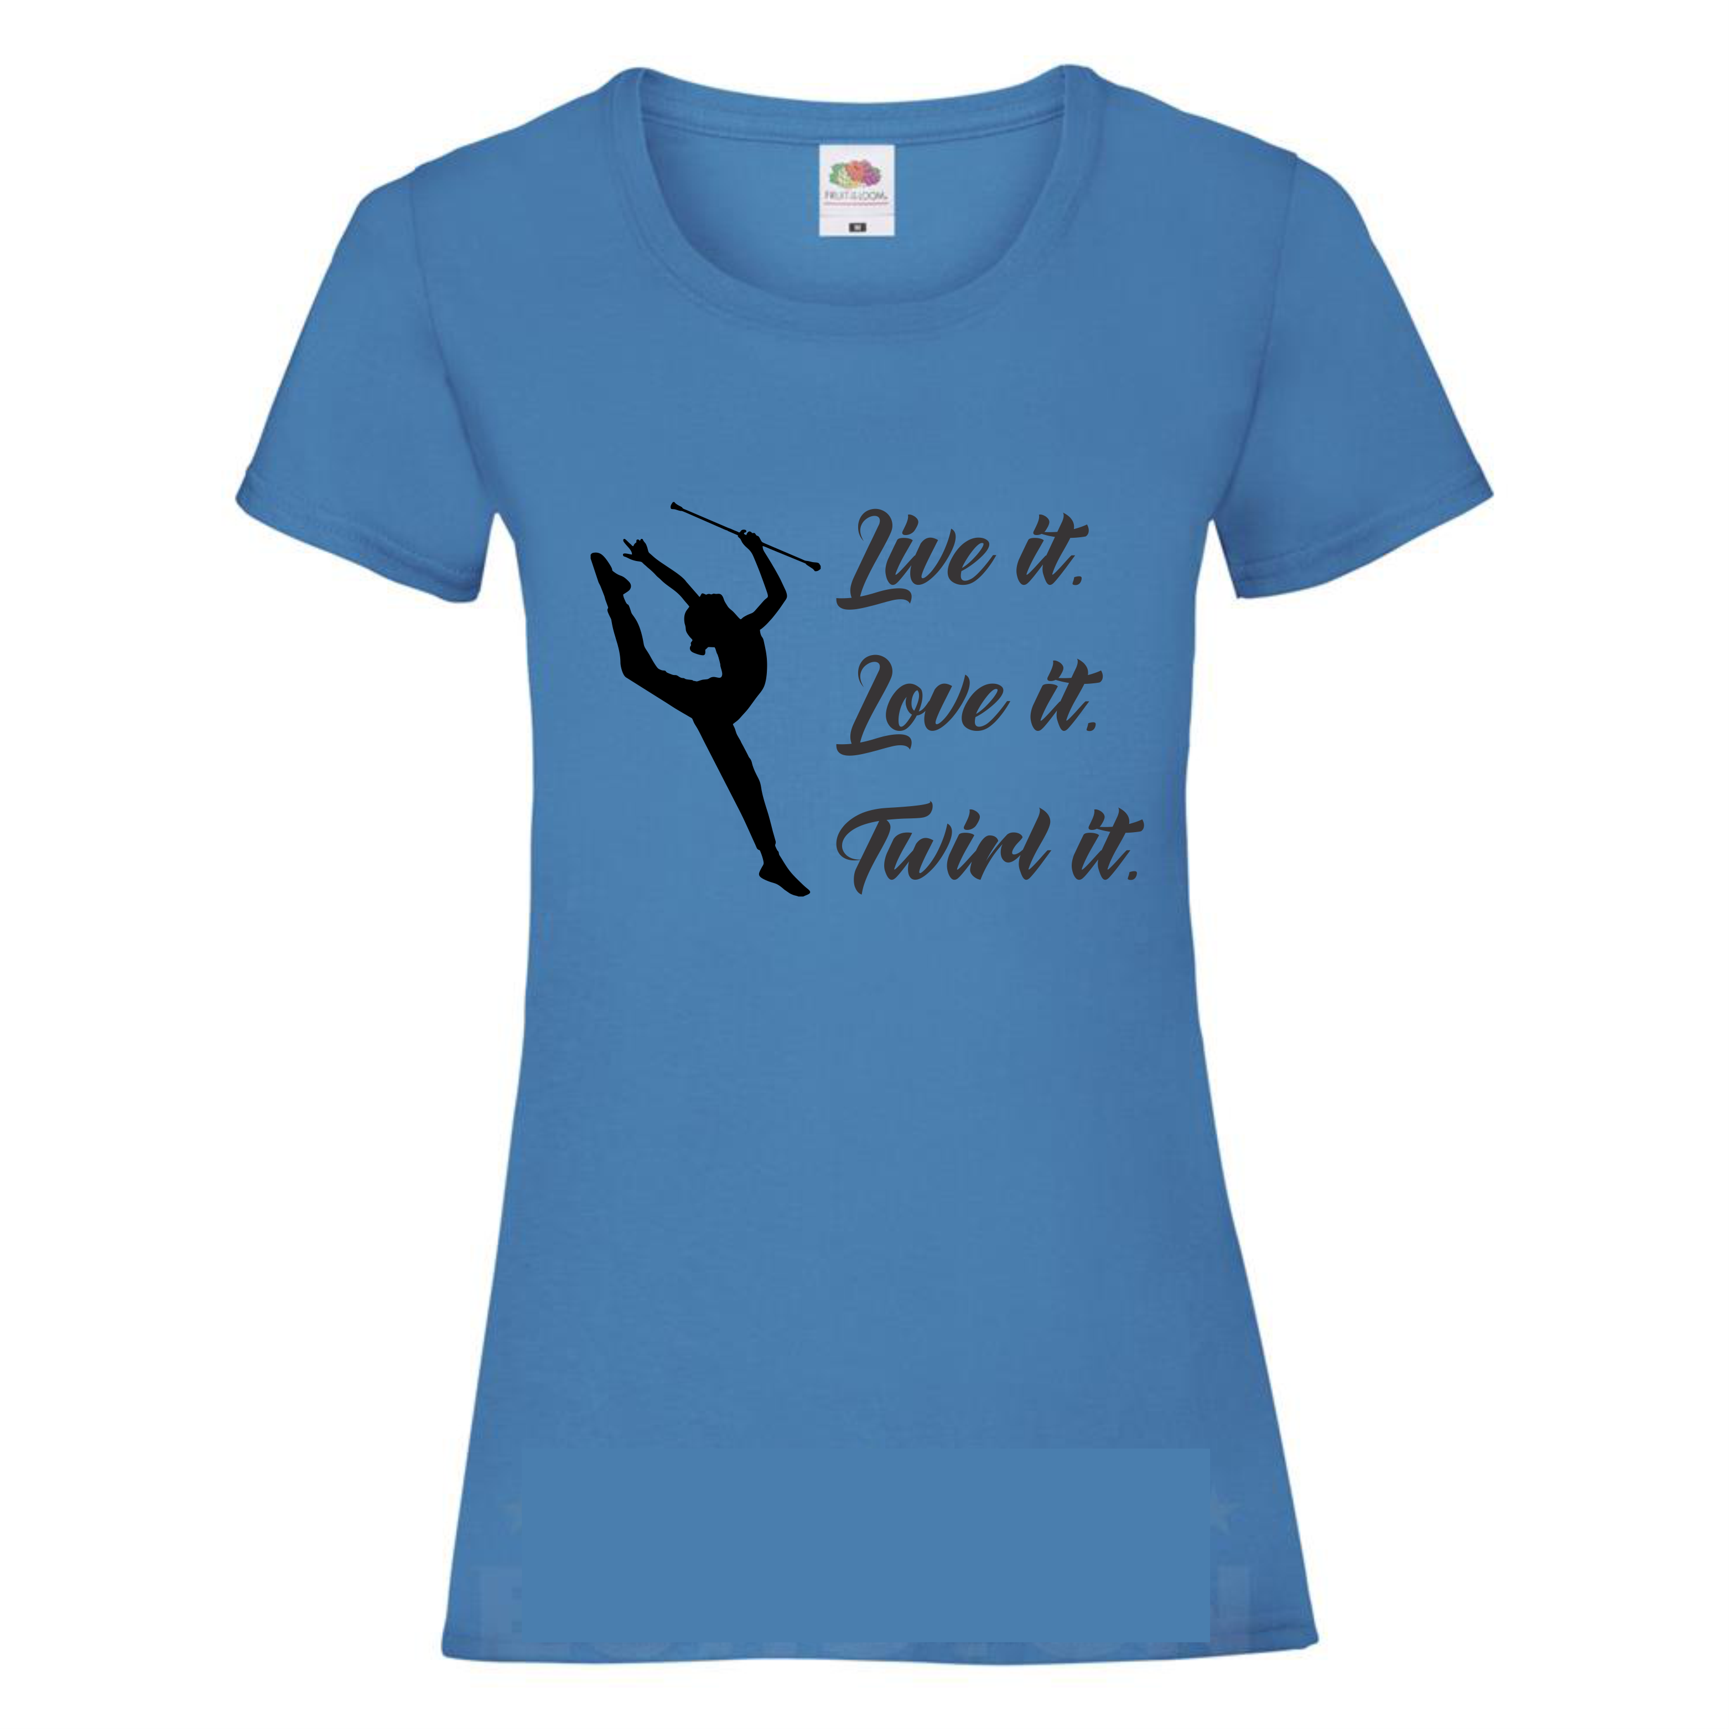
Team or Individual
Address
Town
Country
VAT Number
Person in charge
e-mail

SIZE | QUANTITY pcs. | TOTAL PRICE
105 – 111 | Blue:  Pink: | 10€ x
112 – 116 | Blue:  Pink: | 10€ x
117 – 122 | Blue:  Pink: | 10€ x
123 – 128 | Blue:  Pink: | 10€ x
129 – 134 | Blue:  Pink: | 10€ x
135 – 140 | Blue:  Pink: | 10€ x
141 – 146 | Blue:  Pink: | 10€ x
147 – 152 | Blue:  Pink: | 10€ x
105 – 111 | Blue:  Pink: | 10€ x
112 – 116 | Blue:  Pink: | 10€ x
117 – 122 | Blue:  Pink: | 10€ x
123 – 128 | Blue:  Pink: | 10€ x
129 – 134 | Blue:  Pink: | 10€ x
135 – 140 | Blue:  Pink: | 10€ x
141 – 146 | Blue:  Pink: | 10€ x
147 – 152 | Blue:  Pink: | 10€ x
S | Blue:  Pink: | 10€ x
M | Blue:  Pink: | 10€ x
L | Blue:  Pink: | 10€ x
XL | Blue:  Pink: | 10€ x
XXL | Blue:  Pink: | 10€ x
 |  | TOTAL:

