T-SHIRT ORDER FORM
Deadline: 20.5.2024.
Payment deadline: 1.6.2024.
Send to wamtmajorettes@gmail.com

Team or Individual
Address
Town
Country
VAT Number
Person in charge
email

SIZE | QUANTITY pcs. | TOTAL PRICE
Children  L |  | 10€ x =
Children  XL |  | 10€ x =
Women  S |  | 10€ x =
Women  M |  | 10€ x =
Women  L |  | 10€ x =
Women  XL |  | 10€ x =
Women  2XL |  | 10€ x =
** Sizes are listed in table below
Send to wamtmajorettes@gmail.com

Women size in cm
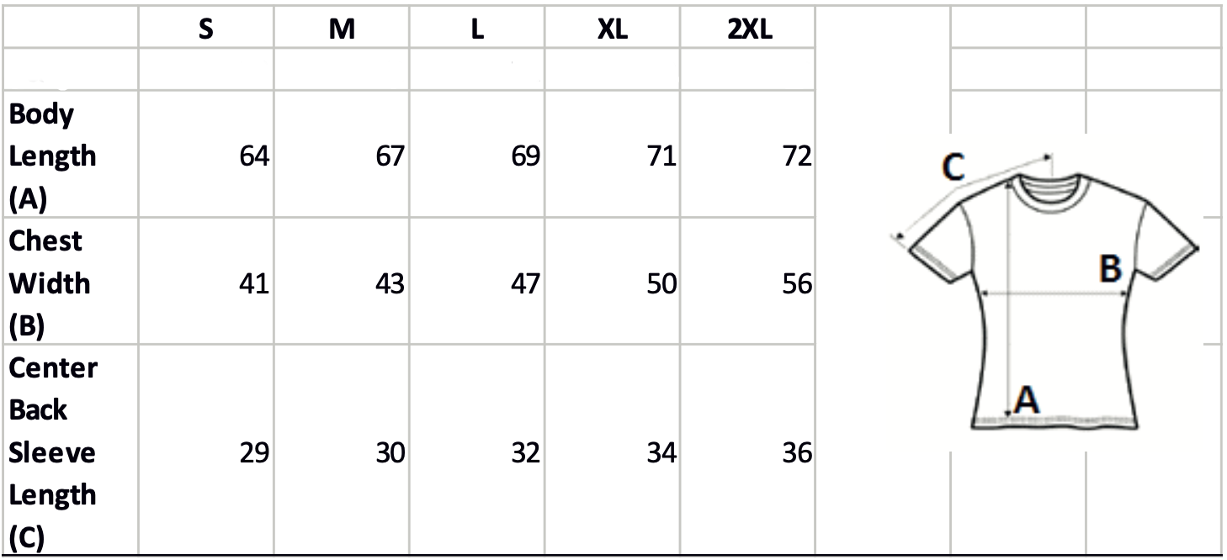

Children size in cm
